**C PROGRAMMING ASSIGNMENT:**

**14**

DATE: 10.12.21

SUBMITTED BY: -

NAME: MUKTESH MISHRA

BRANCH: CSE

SECTION: B22

ROLL NO.: 21052258

1. **WAP sum of elements in array**

***Code;***

#include<stdio.h>

*int* main(*int* *argc*, *char* const \**argv*[])

{

*int* a[10],s=0;

    for (*int* i = 0; i < 10; i++)

    {

       printf("Enter number at %d position of array",i);

       scanf("%d",&a[i]);

       s=s+a[i];

    }

    printf("The sum is %d\n",s);

    return 0;

}

***Output:***

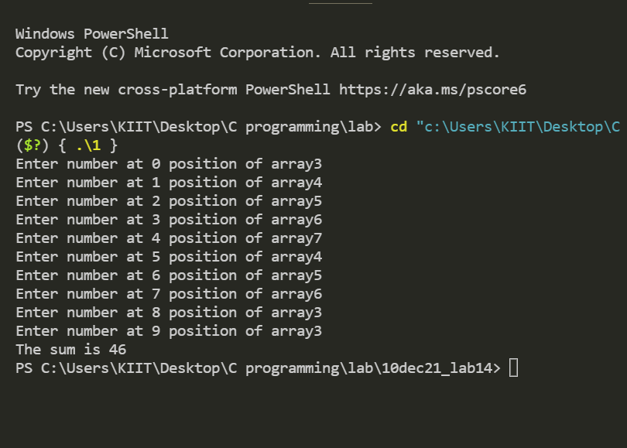

1. **WAP to print reversal array**

***Code:***

#include <stdio.h>

//reversal array

*int* arrayRev(*int* *n*)

{

*int* arg1[*n*];

     for (*int* i = 0; i < *n*; i++)

    {

        printf("Enter element at index %d\n", i);

        scanf("%d", &arg1[i]);

    }

    printf("\nThe original array is: \n");

    for (*int* i = 0; i < *n*; i++)

    {

        printf("%d\t", arg1[i]);

    }

    printf("\nThe reversal array is: \n");

    for (*int* i = 1; i <= *n*; i++)

    {

        printf("%d\t", arg1[*n* - i]);

    }

}

*int* main(*int* *argc*, *char* const \**argv*[])

{

*int* p;

    printf("Enter number of elements in the array\n");

    scanf("%d", &p);

    arrayRev(p);

    return 0;

}

***Output:***

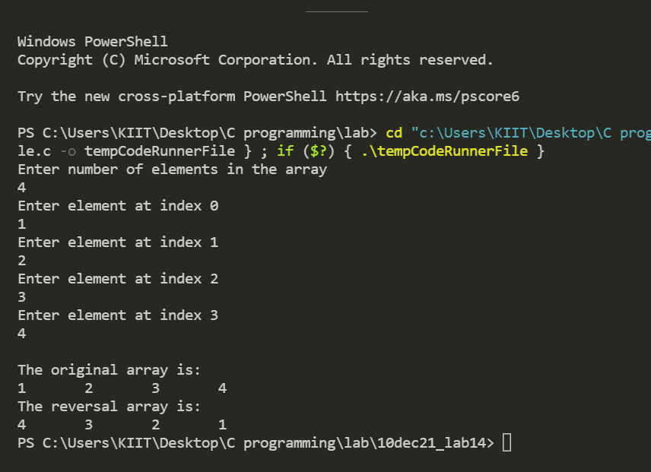

**3.WAP to find max of 5 elements using array**

***Code:***

#include <stdio.h>

*int* main(*int* *argc*, *char* const \**argv*[])

{

*int* a[5], largest=0;

    for (*int* i = 0; i < 5; i++)

    {

        printf("Enter element at %d index:\n", i);

        scanf("%d", &a[i]);

    }

    for (*int* i = 0; i < 5; i++)

    {

        if (a[i] > largest)

        {

            largest = a[i];

        }

    }

    printf("largest:%d\n", largest);

    return 0;

}

***Output:***

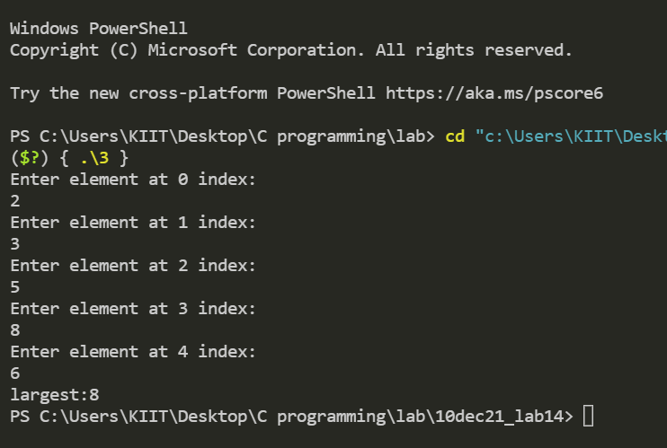

1. **WAP to check for elements if it is present in the array**

***Code:***

#include <stdio.h>

//check for elements if it is present in the array

*int* main(*int* *argc*, *char* const \**argv*[])

{

*int* n, p, c = 0;

*int* a[50];

    printf("Enter n\n");

    scanf("%d", &n);

    for (*int* i = 0; i < n; i++)

    {

        printf("Enter elements at %d index:\n", i);

        scanf("%d", &a[i]);

    }

    printf("Enter search element");

    scanf("%d", &p);

    for (*int* i = 0; i < n; i++)

    {

        if (p == a[i])

        {

            c++;

            printf("The element is present in index %d.\n", i);

        }

    }

    if (c != 0)

    {

        return 0;

    }

    else

    {

        printf("The element is not present in array");

    }

    return 0;

}

***Output:***

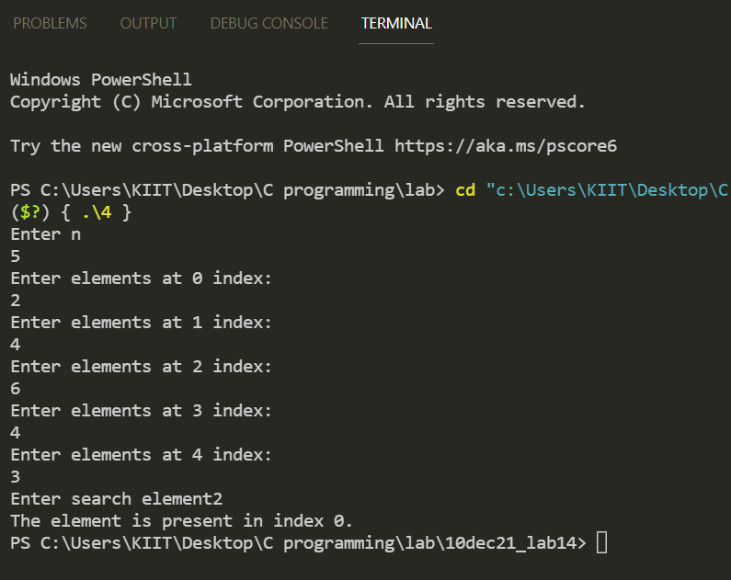

1. **WAP to print Average marks using arrays**

***Code:***

#include <stdio.h>

*int* main()

{

*int* i,avg,count=0,sum=0,marks[20];

    for(i=0;i<20;i++)

    {

        printf("Enter marks: ");

        scanf("%d",&marks[i]);

        sum=sum+marks[i];

        if(marks[i]>89)

            count++;

    }

    avg=sum/20;

    printf("Average marks= %d\n",avg);

    printf("Numer of students secured O grade= %d\n",count);

    return 0;

}

***Output:***

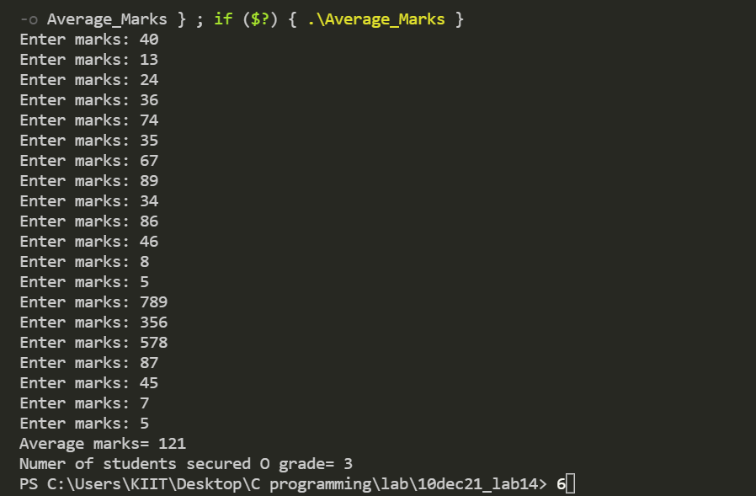

1. **WAP to print sum of 3 numbers using function prototype**

***Code;***

#include <stdio.h>

*void* sum()

{

*int* n1,n2,n3,sum;

    printf("Enter 3 numbers:  ");

    scanf("%d %d %d",&n1,&n2,&n3);

    sum=n1+n2+n3;

    printf("The sum of %d,%d and %d is %d.",n1,n2,n3,sum);

}

*int* main()

{

    sum();

    return 0;

}

***Output;***

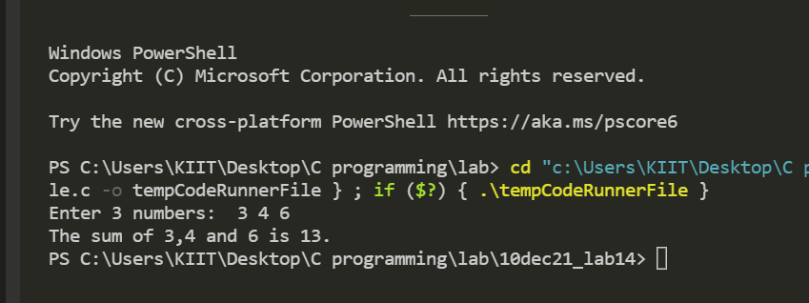

1. **WAP to print X raised to Y using function prototype**

***Code:***

#include <stdio.h>

#include <math.h>

*void* power()

{

*int* n,k,ans;

    printf("Enter base: ");

    scanf("%d",&n);

    printf("Enter exponent: ");

    scanf("%d",&k);

    ans=pow(n,k);

    printf("%d raised to %d is %d.",n,k,ans);

}

*int* main()

{

    power();

    return 0;

}

***Output:***

